**Counting** ____________________________________________________________

This section involves the listing of possible results. It is important to use a systematic approach so that no possibilities are missed.

**1.** **One-Part Counting** – counting one item or one way at a time.

**EXAMPLE:** simple list

A club has 5 members Alan, Bill, Cathy, David, and Evelyn

**2.** **Two-Part Counting** – counting two items, consider using a table

**EXAMPLE:**

Using the same club members as above: the set of club members = {A, B, C, D, E}

How many ways can a president and a secretary be elected? _____________

This time we can make a chart instead of a simple list. A chart is an organized method of showing all the different ways something occurs so not to miss any possibility.

For this example, a person elected cannot be both president and secretary. The first person is president and the second person is secretary.

SECRETARY

|  |  |  |  |  |  |  |
| --- | --- | --- | --- | --- | --- | --- |
| PRESIDENT |  | ***A*** | ***B*** | ***C*** | ***D*** | ***E*** |
| ***A*** |  |  |  |  |  |
| ***B*** |  |  |  |  |  |
| ***C*** |  |  |  |  |  |
| ***D*** |  |  |  |  |  |
| ***E*** |  |  |  |  |  |

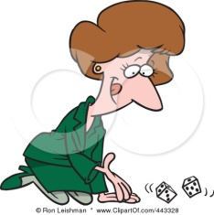**EXAMPLE:** Determine the number of different possible results when two dice are rolled. Let’s say one dice is red and the other dice is white so we can tell each dice apart from one another.

Since we are still looking at counting two objects,

two dice, we can construct a table of the possible

results. Fill in the table with the results:

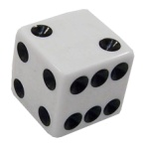

|  |  |  |  |  |  |  |  |
| --- | --- | --- | --- | --- | --- | --- | --- |
| **http://www.psdgraphics.com/wp-content/uploads/2010/02/dice-icon.jpgRED**  **dice** | **WHITE dice** | | | | | | |
|  | **1** | **2** | **3** | **4** | **5** | **6** |
| **1** |  |  |  |  |  |  |
| **2** |  |  |  |  |  |  |
| **3** |  |  |  |  |  |  |
| **4** |  |  |  |  |  |  |
| **5** |  |  |  |  |  |  |
| **6** |  |  |  |  |  |  |

How many possible ways are there to roll two dice? __________

How many possible ways can you roll two dice where their sum is 7? __________

How many ways can you roll two dice where their sum is an odd number? __________

How many ways can you roll two dice with a sum greater than 8? ___________

**Keep this table: it will be used in homework for chapters 10, 11, 12.**

**3.** **Multiple-Part counting** – counting with multiple sets.

Sometimes a list or a chart is not useful when counting multiple parts. A tree diagram might be more useful.

**EXAMPLE:** How many different results can come from tossing 3 coins? _________

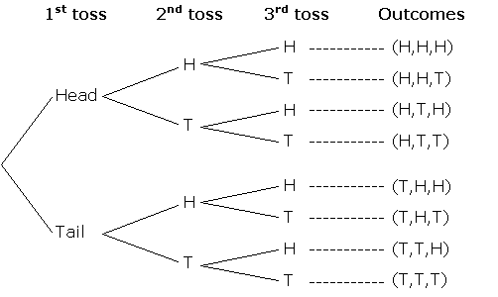





When counting multiple possible results/outcomes, there are two ways the information can be sorted: **with replacement** and **without replacement**.

1. **With Replacement:** _______________________________________________

________________________________________________________________

1. **Without Replacement:** ____________________________________________

________________________________________________________________

**Both of these will be used again in chapter 11 in probability.**

**EXAMPLE:** How many 3-digit numbers can be created using only the numbers 4, 5, 6?

a) Repeated digits not allowed b) Repeated digits allowed

digit digit digit outcomes digit digit digit outcomes

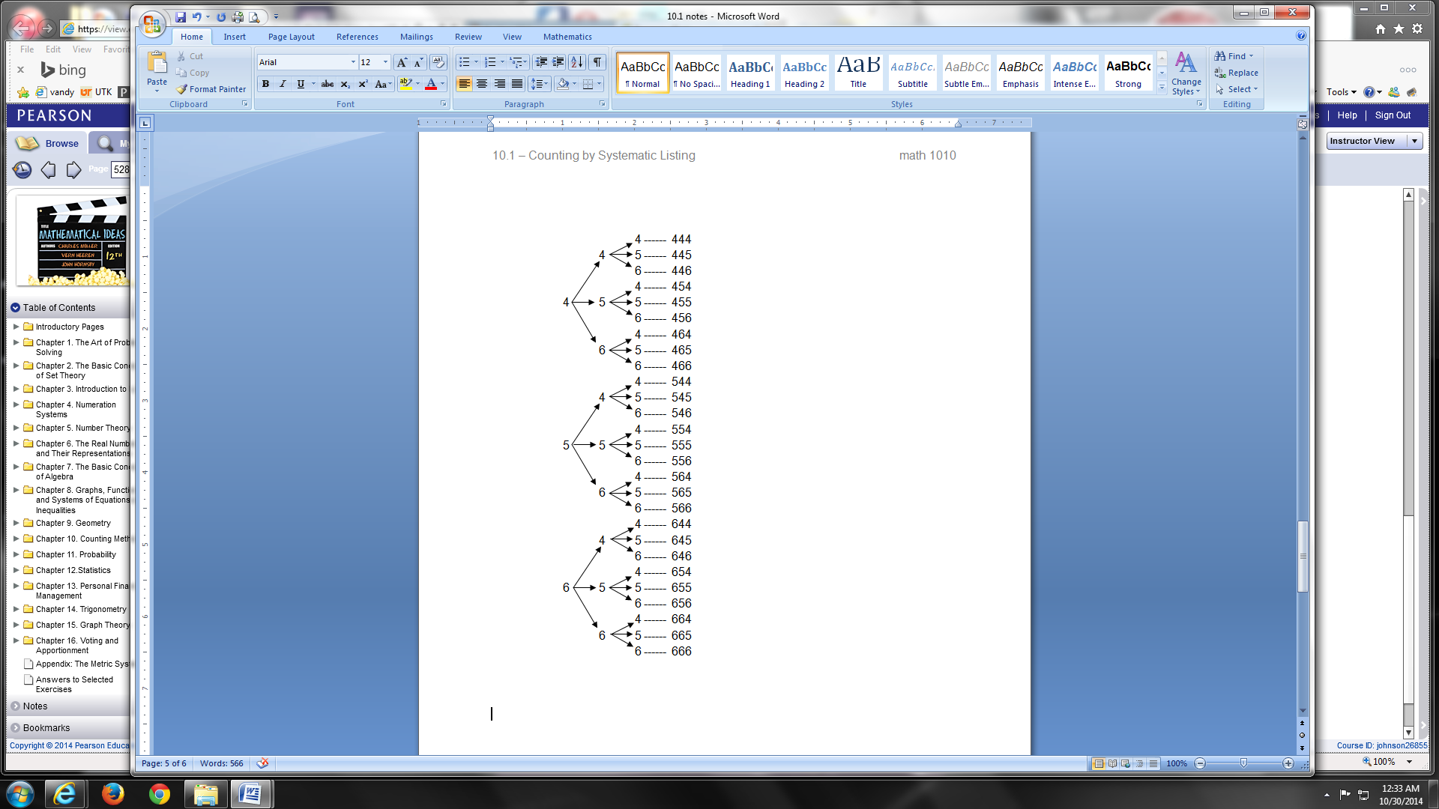 one two three (results) one two three (results)

5 6 ------ 456

4

6 5 ------ 465

4 6 ------ 546

5

6 4 ------ 564

4 5 ------ 645

6

5 4 ------ 654

**4.** **Counting shapes** – another way to systematically count is to count shapes by finding a starting point, looking at different sizes, and label & move around the figure.

**EXAMPLE:** Count the number of triangles (any size) in the figure: ____________

4 ------ 444

4 5 ------ 445

6 ------ 446

4 ------ 454

4 5 5 ------ 455

6 ------ 456

4 ------ 464

6 5 ------ 465

6 ------ 466

4 ------ 544

4 5 ------ 545

6 ------ 546

4 ------ 554

5 5 5 ------ 555

6 ------ 556

4 ------ 564

6 5 ------ 565

6 ------ 566

4 ------ 644

4 5 ------ 645

6 ------ 646

4 ------ 654

6 5 5 ------ 655

6 ------ 656

4 ------ 664

6 5 ------ 665

6 ------ 666

5 6 ------ 456

4

6 5 ------ 465

4 6 ------ 546

5

6 4 ------ 564

4 5 ------ 645

6

5 4 ------ 654